RAPID DECISION TOOL

# How To Use

Rapid Decision Tool is relatively easy to use. When it starts its execution, you will be already given shape files loaded for the province map of Indonesia, Sumatran Subduction Zone line (in red) and Sumatran Fault Line (in yellow). You will also see the Zoom Pan Tool Bar and Selection Bar on the tool. Information about these tool bars is discussed in detail in Chapter 8 of the thesis, but most tools are familiar and easily used.

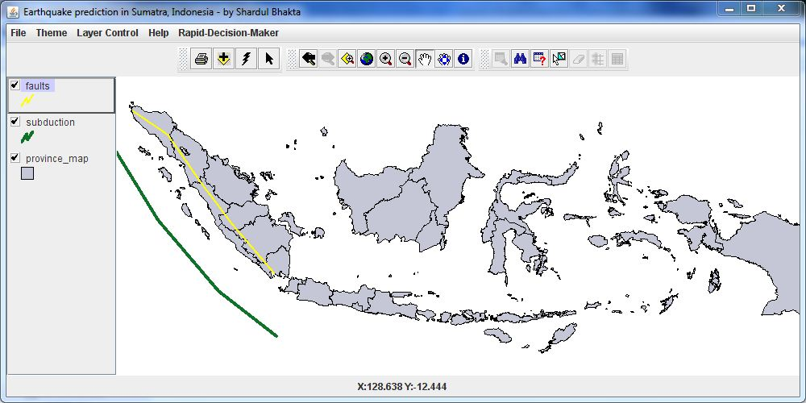

**FIGURE 1 Start Window**

The steps to follow to use the Rapid Decision Tool to predict earthquakes in Sumatra-

1. Open the Rapid Decision Tool by double clicking on the jar file; you will see the start window (figure 1 above)
2. Click on the Menu Item “Rapid Decision Maker” (highlighted in blue in figure 2 below), you will see a drop down item called “Enter Data”. Click on it

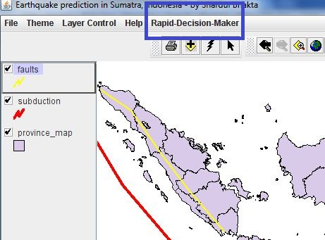

**FIGURE 2 Location of Rapid-Decision-Maker menu item**

1. You will see a new window called “Rapid Decision Window” which will have a text field where the user input will be stored, a button to start earthquake prediction called “Prediction” and a button to read instructions on how to give the input. See figure 3 below.

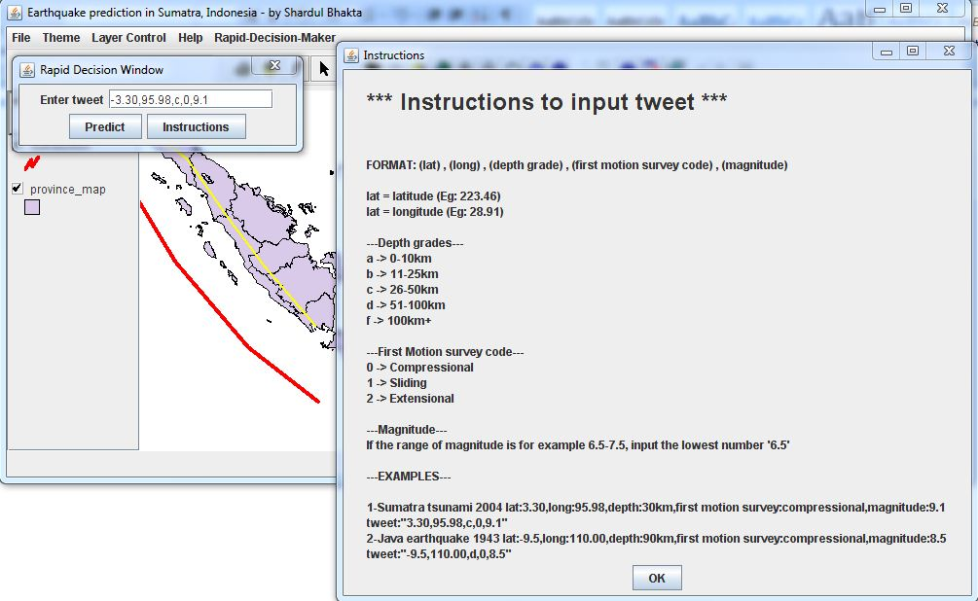

**FIGURE 3 Window showing input instruction**

1. Enter the correct comma separated values in the input string. Verify your latitudes, longitudes, depth grades, code for type of earthquake and magnitude and press the button “Prediction”. You will see points and magnitudes on the map with similar earthquakes as the input string. (see figure 4 below)
2. Use the Zoom In button on ZoomPanToolBar to look at the points closely and locate them on map, their magnitudes are aligned on top of each point.(see figure 4)

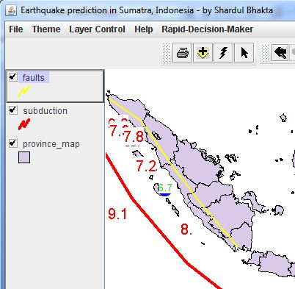

**FIGURE 4 Prediction points displayed on map**

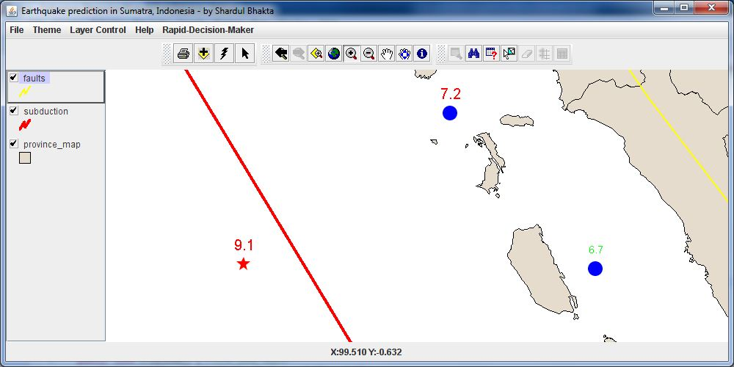

**FIGURE 5 Prediction points zoomed in**

1. You will observe that the red star is the earthquake point that was an input from the user, and the blue points are similar earthquake locations from the past. The hovering text on it is the magnitude. The size of the blue point depends on the depth of the earthquake, bigger the blue dot, deeper the earthquake.
2. The color of the magnitude text also differs with respect to its magnitude. if an earthquake has a magnitude of range 6 – 7, it will be yellow text, which signifies moderate destruction, if it is greater than 7, it signifies danger.
3. You can repeat same steps for another input earthquake; where in the map will be updated with respect to the new input.

# How To Predict

With all the visible blue points and star point on the map with magnitude values on top of them, how can one use all this to predict if the input earthquake would be fatal or not. The blue points signify historical earthquakes. The size of the blue points signify the depth of that earthquake, the bigger the point, the deeper the earthquake. One has to see all the positions of these blue points on the map. It is important to see if the points located on land or ocean. If the earthquake is on ocean and of compressional type, it is definitely fatal because it is similar to 2004 tsunami earthquake. Similarly, if the earthquake seems to be on land or ocean with strike-slip type, it is not going to be as fatal as a tsunami. Extension earthquakes on land may not be very strong, whereas extensional earthquakes on ocean can cause some displacement and a tsunami warning.

The magnitudes on the blue dots have significance to their colors. If the magnitude shows up in red, it is dangerous, whereas if it shows up in yellow or blue, it is less fatal. One has to see the pattern of the underlying similar earthquakes with the input earthquake. After analyzing all these patterns, one can easily predict if the input earthquake is fatal or not.