Tips on Getting Map Viewer to Work

Map Viewer is a tool for viewing Oracle spatial tables, or more precisely SDO_GEOMETRY columns. In order to work, Map Viewer needs to be paired with a Java servlet container made by Oracle, OC4J, standing for Oracle Container for J2EE.

To further confuse things, OC4J is also part of OAS, the (huge) Oracle Application Server. Thus there are many download options.

The best bet is to go to the Oracle web pages and download Map Viewer 10.1.3.1 QuickStart kit, which gives you both Map Viewer and OC4J, pre-adjusted to talk nice to each other. The result of opening this on your PC should be a folder called
mv10131_qs (you are more likely to find mv10133_qs now, a newer version,
or the even newer mv11ps3_quickstart).
It is necessary to set up an oc4jadmin account with a password of your choice.
You can do that on the first start of mapviewer.

Should you forget that password, it can no longer be reset from mapviewer. That has
been deprecated. Instead you must go thru oc4j. I have not fully explored that, but I
have started oc4j directly. As with mapviewer, the first start may invite you to choose
a password (maybe not, if you did this thru mapviewer). Here is how to start oc4j.
Go to the oc4j subfolder, and do exactly what it says to do in the readme file
in that directory. This will involve setting JAVA_HOME and ORACLE_HOME as
mentioned below. Open up a command window. You can then set these two environment variables as follows:
set JAVA_HOME=C:\progra~1\Java\jdkl.5.0_06 (point to a java that is 1.5 and up)
set ORACLE_HOME=C:\mv10133_qs\oc4j
and then in the run window navigate to
C:\mv10133_qs\oc4j\bin
and execute oc4j –start
The advantage of this approach is that you are not permanently changing the
environment variables. You may be invited to set the oc4jadmin password
after that execution. Hopefully you will NEVER have to start oc4j directly.

The mv10133_qs folder will contain a readme, a start.bat, and an OC4J folder. You will be instructed to set JAVA_HOME to point somewhere, and ORACLE_HOME to point into this package. This advice can be ignored if you have some driver like classes12.zip in your CLASSPATH value. This is recommended since it leaves ORACLE_HOME pointing at your Oracle install, and it is never a bad idea to have an Oracle driver in your CLASSPATH.

Here is what the start.bat file looks like initially (if it says mv10131_qs and you have
mv10133_qs, then fix it):

C:
cd C:\mv10133_qs\oc4j\j2ee\home
C:\Program Files\Java\jdk1.5.0\bin\java -server -Xmx384M -jar oc4j.jar

The first line takes you to the directory where oc4j.jar is, which is the “real” code for getting map viewer up and running. The second line is a complete classpath to some occurrence of the java run command. The default path must become a correct path for your PC, and you must point at a java jdk 1.5 or higher. An example of the right path might be

C:
cd C:\mv10133_qs\oc4j\j2ee\home
C:\Program Files\Java\jdk1.5.0_06\bin\java -server -Xmx384M -jar oc4j.jar

An alternative more likely to still be downloadable it mv11ps3_quickstart

So assuming the start.bat file is at C:\mv10133_qs, you open a command window, navigate to this folder, and type: start.bat
Or you can navigate to C:\mv10133_qs\oc4j\j2ee\home and type:
C:\mv10133_qs\start NOTE: the process takes some time!

This should start both OC4J and map viewer, and output a lot of stuff. In the old days
the odds were good that you would be asked to choose a password for the oc4j administrator, whose username is preset as oc4jadmin But now you should
probably follow the plan outlined above.

Assuming your messages include encouragement that oc4j and map viewer are both running, open up Firefox or some lesser browser. In the browser type the URL:
http://localhost:8888/mapviewer
and you should see a Welcome page for Map Viewer which starts with
Welcome!
Your Map Viewer server is now running................................
Now you need to establish a data source. There are two plans.

PLAN A:
In the upper right corner click on an icon with a key on it and the word Admin underneath it. You will see a username (type oc4jadmin) and a password, that you hopefully still remember. There is a Plan B below if this makes trouble!
NOTE: for Oracle 11g, the following website has tips that have been successfully
used to create or reset the password for oc4jadmin:
http://mike-lehmann.blogspot.com/2006/12/reset-oc4j-admin-password.html

You will then have a chance to click on Data Source, to tell the application where your SDO_GEOMETRY tables are. What you will get is a simple form filler where you choose a data source name, e.g. sdsu as seen below. Other fields are host (type localhost), sid (your Oracle instance name), your Oracle port number (almost certainly 1521) and your Oracle username and password. With luck you will see you have created a data source named e.g. sdsu. If this gives you trouble, try Plan B below. NOTE: use your own oracle username and password, not scott/tiger

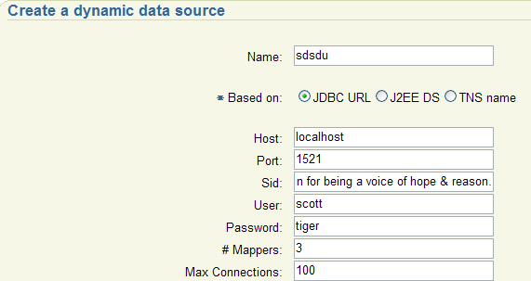

PLAN B:
You can avoid the login by hitting “Cancel” next to the login textfields. If you
have a datasource established, as below, you can the click on Demos, and start using
mapviewer!!!
In window explorer (my computer) navigate your way to what will be something like:
C:\mv10133_qs\oc4j\j2ee\home\applications\mapviewer\web\WEB-INF\conf
where conf is short for configuation. You will find a file called Config.xml which you should open with an editor. At the very bottom of this file there is a commented out suggestion for creating a ‘permanent’ data source, one that you need not re-install. Here is the code for one that might serve.

<map_data_source name="sdsu"
jdbc_host="localhost"
jdbc_sid="cfedb"
jdbc_port="1521"
jdbc_user="eckberg"
jdbc_password="zB95LL9pfp8x4gIH6/WQFag6ZhxSRXBE"
jdbc_mode="thin"
number_of_mappers="3"
allow_jdbc_theme_based_foi="false"
/>

CAUTION: what you see for password is a fake, after password encryption. If your real
Oracle password is cs615, then what you enter after jdbc_password is !cs615. After the data source is established !cs615 is replaced by an encrypted string like the one above, so
that your password is better protected.

SHORTCUT: there is a button with Configuration on it, just above the map viewer
button that says Datasources

Also note that cfedb is the oracle instance name; the default instance name is often orcl.
This code will be automatically read each time you start up map viewer and will establish
the datasource called sdsu. This is the best way to create a data source. You may need to restart map viewer to make this effective. You can kill the old map viewer by killing its command window, or typing control-C in that command window. Plan A and Plan B might not be fully compatible. Multiple data sources can be hard coded into Config.xml

Once you have a Data Source by one means or another, in the Welcome to Map Viewer page, you will find some tabs in the upper right hand corner. Click on the Demos tab.
You will get a new page on demos; click on the first one, called JView. You should see something like what appears below:

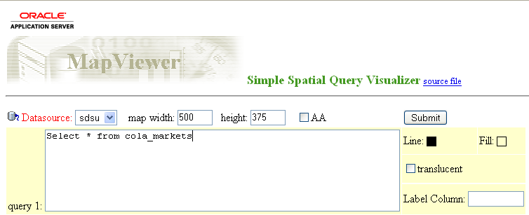

As shown above, you select a Datasource, the one in this example is called sdsu, and then simply type an SQL command (with no semi-colon) into the first text area, and then hit the Submit button in the upper right corner. You should see something like what appears below, which is the well known classic Oracle example of an SDO_GOEMETRY table in local coordinates. Notice that in the simple viewer, there are but 3 tools, zoom in, zoom out, and a pan tool.

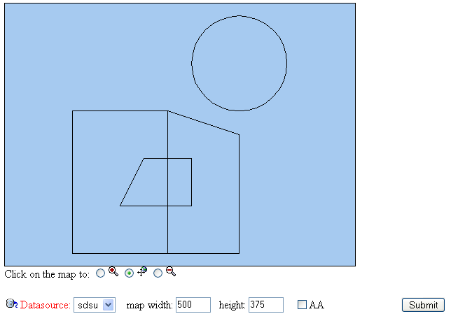

In the original JView frame, to the right of the text area, if you check the box next to Fill
you can choose a color for filling in closed polygons in the resulting view of your theme.

