INSTALLATION AND USE OF EXECUTABLE JARFILE FOR CHARTS

The zip folder, ChartTool.rar, can be downloaded by clicking on the link below at this website. Once you download it, unzip it to get the folder ChartTool. Double click on the executable jarfile in this folder to launch the application. Allow some time for the application window to open.
NOTE: the executable jarfile is inside the source folder inside ChartTool.

You will see a window with a map to the right, and a ‘table of contents’ to the left. The zip folder contains shapefiles of Canada and India, then you can both add and remove map layers. One way to do this is to click on the File menu. The layer names will appear in the table of contents. In the tool bar, there is an icon for the chart tool, as follows: .

Associated with each layer, e.g. Canadian provinces, is a data table, and in this case its name will be province.dbf . Click on the chart tool button, as seen above, in the toolbar beneath the menubar. You will get a file browser, and you should navigate to, e.g. province.dbf, and click on that file. The result will be the following window. The initial window just has the two images at the top, and if you click on the right image, you are asking for a bar chart, and the middle of the window seen below will appear. There are 4 dropdown lists and you should make a selection from each of them, in order. The third list includes NAME and clicking on that means names of provinces will be shown on the bar chart on one axis. Similarly if you click on AREA, that will show up on the other axis.

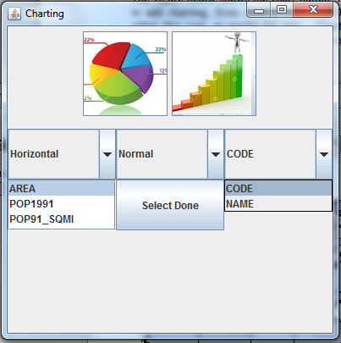

The last step is to click on Select Done, which will open up a chart window. One of the character columns, in this case Name, will be one axis of the bar chart, and Area will be the other axis. You will have some control over the title of the display always, and you can change the x and y axis labeling for vertical bar charts. Here is the chart:

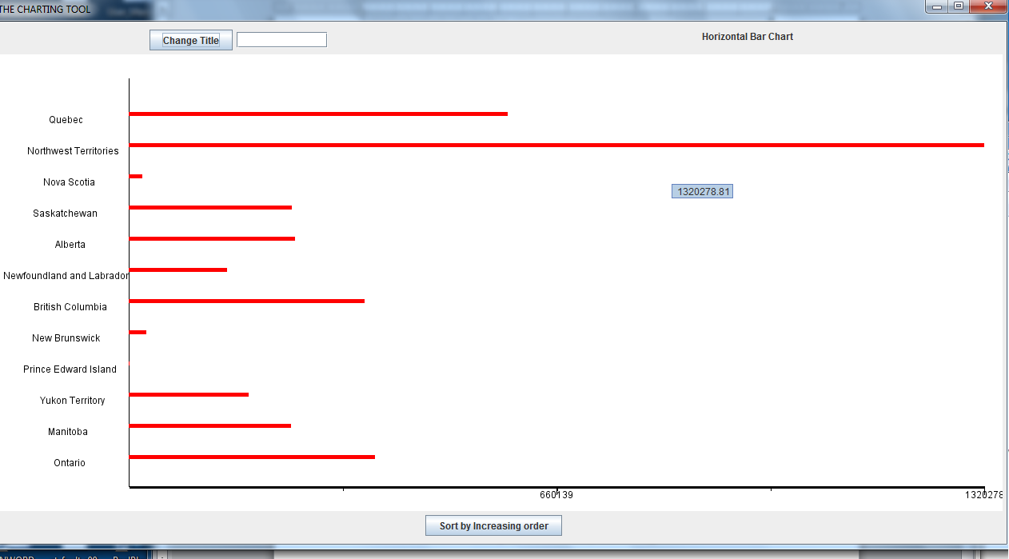

Under the File menu of the map window is a Legend Editor. If you click on the province layer in the table of contents, you will get a chance to put labels on the map layer. That will show the locations of the provinces, and make it easy to tie the chart values above to locations on the map.

Here is an image below showing both windows together on the screen. To see more labels, you can zoom in on the map. This is a nice way to display statistical data, and at the same time, tie it to locations on a map.

What has been described here is a very general algorithm. There are many shapefiles available from the web. For example, go to www.gadm.org They have many shapefiles for countries throughout the world. The name gadm abbreviates “government administration “ shapefiles, in effect. You can download shapefiles for the country of your choice, e.g. china1.shp, and you will also get a data file called china1.dbf. You can then generate pie charts or bar charts from that data file.

NOTE: the initial chart window can be adjusted for size, and often should be, since the default display size is often not what you need.

The map window can also be resized, and zoomed and panned. Sometimes the toolbar button whose tooltip text is ‘Zoom to Full Extent’ will display the map better in its frame.

The application has a number of other tools and features in the map window, and in the chart window
you can click on Sort by Increasing Order to re-arrange the bars. The chart window has a ‘split pane’ bar down the middle of the window. Dragging this bar left will expand the chart and make it wider. If you are not used to GIS applications, play around with the available tools. The print Chart button will
print your entire screen, not just the chart, so get the screen the way you want it, first.

In the pie chart below, the colors of the province names match the colors in the pie chart. Bar charts work better when there many features in the map layer.
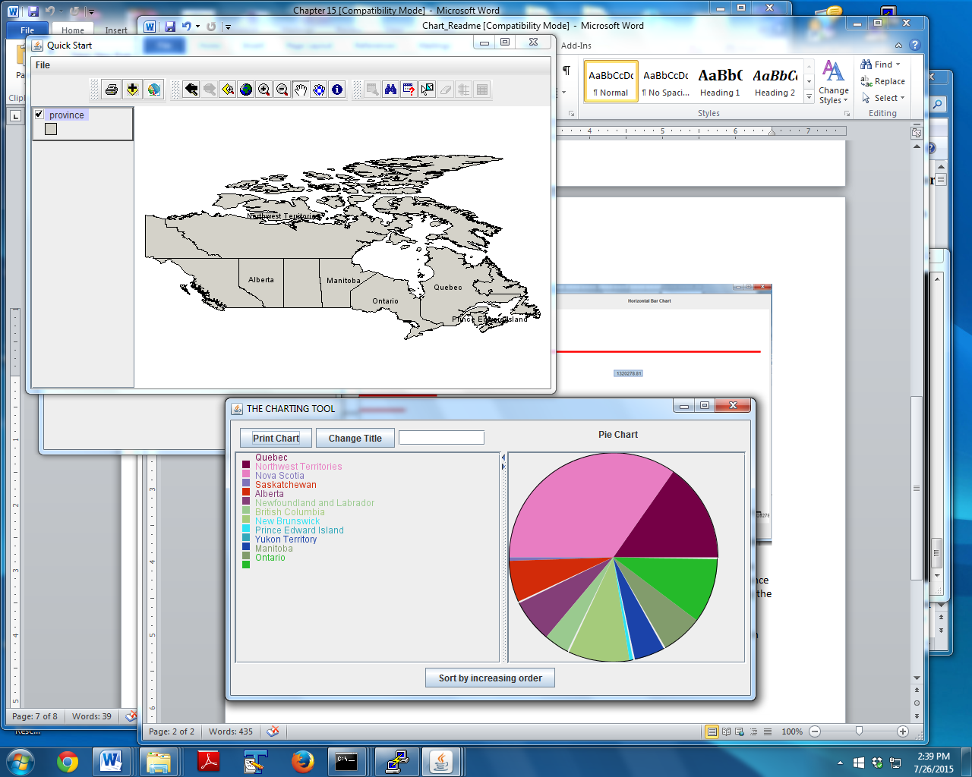

In some cases, you might want to create a chart for your own data. While .dbf and .csv files are both Excel readable, this tool works only for .dbf files. But there are free tools for adding columns to an existing dbf table. DBFPlus and dbfexplorer are two examples.

This charting tool is quite flexable, and sinceit uses a Java jarfile, it should execute correctly on almost any computer or laptop.

