INSTALLATION AND USE OF EXECUTABLE JARFILE FOR CHARTS

Instructions on how to view the demo of the charting tool as a stand-alone application are mentioned below:
- Right-Click on the Extended Charts zip file link and select the option “Save link as..” Select the folder where you want this zip file downloaded to.
- Once zip file is downloaded unzip it.
- Navigate to the ExtendedCharts jar located in the jar folder and double click on it to launch the application
- Once the application opens user can see a map with the layer information on the left.
- To get started with the charting tool click on the icon the in tool bar section
- Once the user clicks on the charting button a File Browsing menu is opened where the user is required to select a dbf file using which charts can be displayed. Sample dbf files are in the data folder bundled in the zip file e.g. states.dbf
- Once user selects the dbf file the main screen of the charting application is displayed as shown below
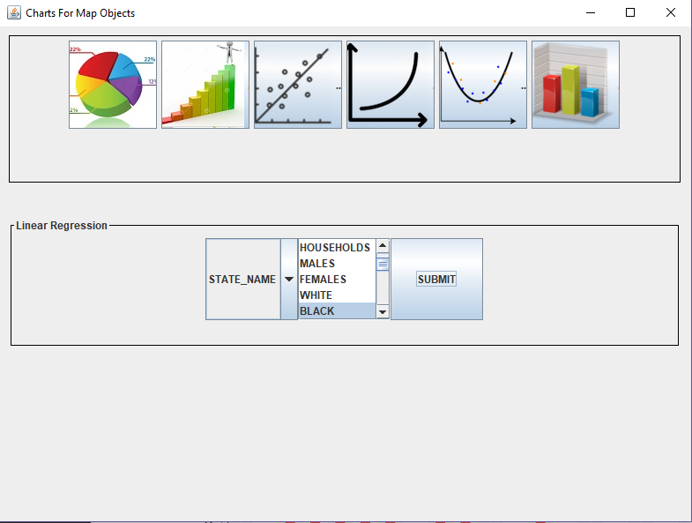
- This version of the charting tool provides the user option to perform regression analysis and render three-dimensional charts.
- The charting options provided by this version of the charting tool starting second from the left in the image above are Linear Regression, Power Regression, Polynomial Regression and Three-Dimensional Charts
- The user is presented with a attribute selection screen which are basically choices for the x and y axis while rendering the charts
- Once the user selects appropriate parameters based on his or her preferences the SUBMIT button needs to be clicked to display the chart
- As soon as the submit button is clicked the chart is displayed to the user
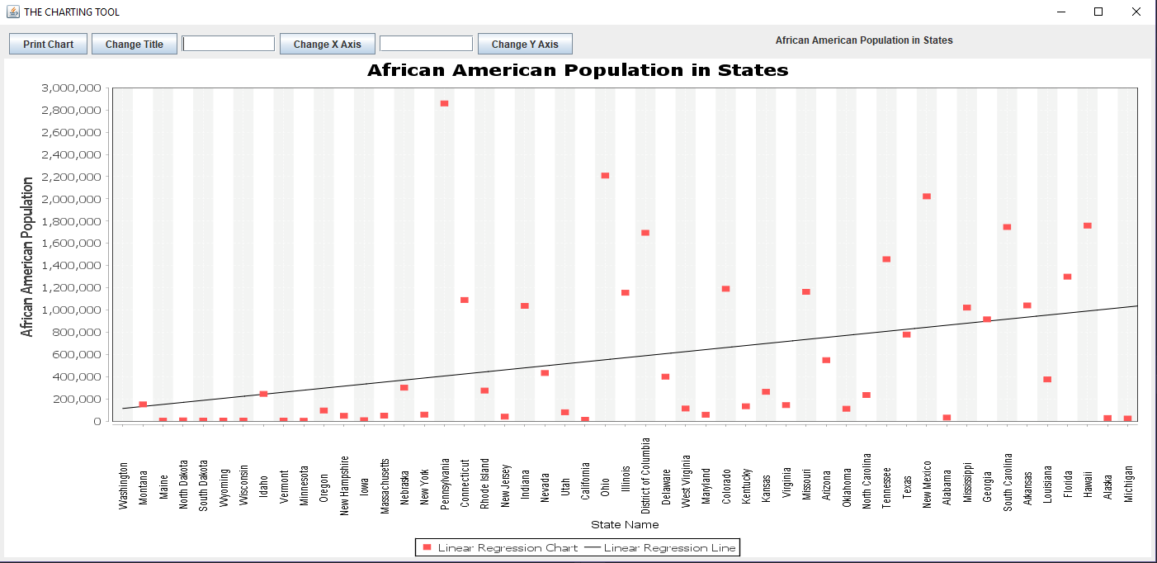
- The user can change title of the chart along with the labels of the x and y co-ordinate axis.
- Printing functionality is provided by the application if the user wants to document the chart for reference.
- The user can resize the chart screen at any time based on their preference
- The tool also provides the user to display three-dimensional bar and pie charts. Bar charts work good when the user wants to do comparisons and pie charts work best for establishing relationships between the dataset based on the value.
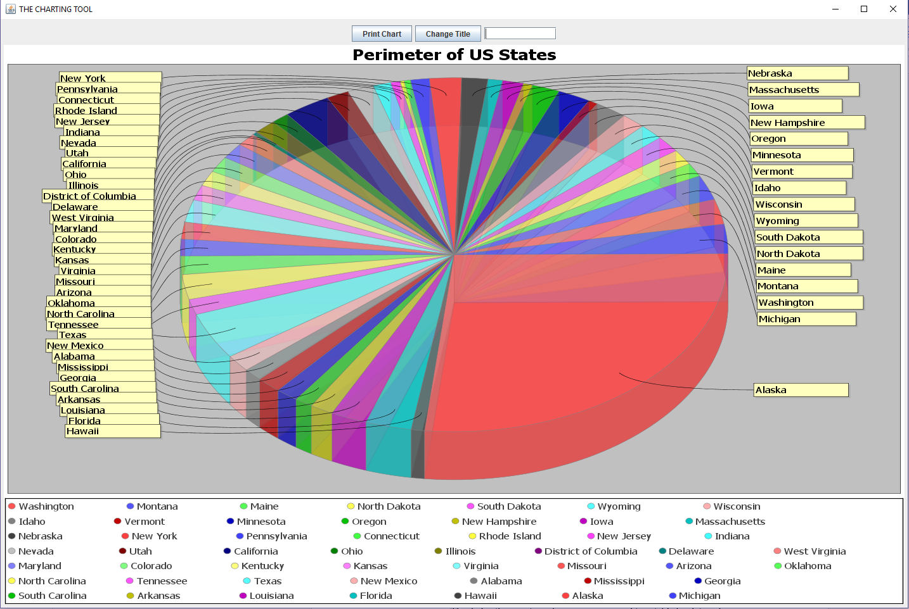
- Although there are a few dbf files provided in the zip file user can download his or her own dbf files from MapCruzin or through the GADM website
- If the user wants to create his or her own charts it can be done using excel by opening the dbf file and then making additions such as adding columns, etc.
- Since this is a executable jar file it only requires a java installation and can be executed from technically any system

